**Fe-OM associations may act as a mechanism for DOC mobilization in coastal upland forest**

Connor O’Loughlin

Mentor: Allison Myers-Pigg

# Abstract

Coastal environments are experiencing increased storm surge and saltwater flooding due to climate change, which may influence soil carbon stability and turnover mechanisms. These mechanisms include changes in ionic strength and soil organo-mineral complexes which may release organic matter (OM) associated with soil minerals into solution. Terrestrial Ecosystem Manipulation to Probe the Effects of Storm Treatments (TEMPEST) is a large ecosystem scale experiment located in Chesapeake Bay that is designed to mimic the impact that potential flooding disturbances (storm surges) would have on upland coastal forest. Field observations indicated that there was a change in dissolved organic carbon (DOC) released after flooding the TEMPEST experimental forest with saltwater for a year following experimental inundation. To explore potential mechanisms behind these observations, upland soil collected from the control plot of TEMPEST was washed with saltwater, while oxygen exposure was altered to mimic shifts in oxygen availability that occur during flooding. Subsequent washes with DI water were performed to simulate subsequent precipitation events, and each wash was centrifuged to examine DOC present in colloidal fractions (0.45-1.0 mm, 0.1-0.45 mm, and <0.1 mm) to understand which size fractions the bulk of DOC is mobilized in. Carbon was quantified and characterized using total organic carbon (TOC) and colored dissolved organic matter (CDOM) and the mineral components were analyzed using the ferrozine assay and inductively coupled plasma mass spectrometry (ICP-MS). We found that DOC concentrations peaked several washes after the initial saltwater wash, and that the 0.1-0.45 mm fraction contained the bulk of the mobilized DOC across the different fractions. The observed correlation between Fe(III) and DOC, specifically aromatic DOM, suggests that there may be disassociation of aromatic ligands following transformation of Fe(II) to Fe(III) that may be important for DOC mobilization. Results from these experiments suggest that the inundation of coastal upland forest may trigger changes in Fe-OM associations across different ionic strengths that may impact soil carbon stability in coastal forest soils following salinity exposure. Better understanding of these mechanisms will increase understanding of how changes in storm surge and sea level rise driven by climate change may impact carbon cycling along threatened the coasts.

# Introduction

Climate change has led to rising sea levels1, increased frequency and intensity of severe weather2, and increases in both precipitation and annual temperatures3 which together change how ecosystems function4–6 . Carbon cycling could be impacted by making previously “unavailable” carbon susceptible to lateral movement through the soil or microbial metabolism which would deplete the C stocks7,8. Terrestrial carbon pools play a critical role in regulating the concentration of atmospheric carbon9 and typically exceed 50% of ecosystem C content in temperate forests10. Given the importance of upland forest soil carbon as a reservoir of global carbon storage, understanding possible losses of this carbon pool due to salinity exposure must be explored .11The combination of rising sea level and intensity of storms brings an increase in storm surges that push saltwater far beyond the natural limits of the tides12. Storm surges may impact soil carbon stability in two ways: 1) changes in ionic strength, 2) shifts in redox conditions due to increase saturation. Storm surges inundate coastal forest with saltwater13 causing changes to the ionic strength of the soil that have been shown to influence C, N and P cycling in coastal wetlands14,15. Marine salts have displayed varying effects on soil aside from just changing the ionic strength of the porewater (pH, cation exchange capacity, introduction of terminal electron acceptors) and the extent of change is most likely due to characteristics of the site itself and its history to salt exposure15. 1617Changes in redox state can influence iron-organic matter coupling, which may further influence carbon cyling in systems impacted by storm surge. For example, Bhattacharya et al (2018) found that frequent shifts in redox state might promote C loss from soils via desorption and leaching of DOC. Understanding the impact of shifts in redox potential and how they might trigger Fe-C and/or Fe-OM interactions to act as a mechanism for DOC mobilization is a very important aspect to investigate18,19 considering the ubiquitous nature of Fe as a key mineral in biogeochemical cycling20,21. Additionally, Fe(III) has been shown to associate with aromatic compounds along salinity gradients 15. Under reducing conditions, Fe(II) tends to readily dissolve but once subjected to oxidizing conditions it will precipitate out of solution and begin to aggregate typically as mineral colloids (Ferrihydrite, FeOOH) or adsorb OM (suspected to be aromatic OM)21. The aggregation of dissolved Fe to colloids (0.1-0.45 mm) and particulates (0.45-1.0 mm)22, as well as the relationship between Fe(III) andOM suggest that particle size may play an important role in the mobilization of DOC. The mobilization of colloidal OC (COC) has been linked to an accompanied increase in the concentration of Fe and Al while under oxic conditions23. Subsequent fluctuations between anoxic and oxic states will promote the dissolution, recrystallization, and transformation of Fe minerals and ultimately increase the mobilization of DOC and organic Fe/Al colloids7,24. The link between Fe, DOC, colloidal aggregation, and redox fluctuations are very close knit and can be altered by variables such as ionic strength25.

We suspect that following saltwater inundation (correlated to an increase in ionic strength), an increase of OM coagulation resulting from ionic strength equilibrating will directly result in lower concentrations of DOC16. Following precipitation events and consequently the addition of a lower ionic strength solution, we predict that the equilibrium will shift and for cations to redissolve into solution17 and allow for OM to once again reabsorb to the mineral surface and therefore increase DOC concentration. Given this, we hypothesize that 1.) DOC mobilization will most likely reach its peak several washes after the initial seawater wash and that the bulk of the carbon will be in the 0.1-0.45 mm fraction 2.) Samples that remained in anoxia will have the most mobilized carbon because of the biogeochemistry between organic matter and Fe2+ (colloidal dispersion and cation exchange)26 and 3.) we will observe a relationship between Fe(III) and aromatic DOM across all size fractions.

# Materials and Methods

To test our hypotheses above, we designed an experiment to study the complex relationships in a laboratory setting.

## Soils Samples

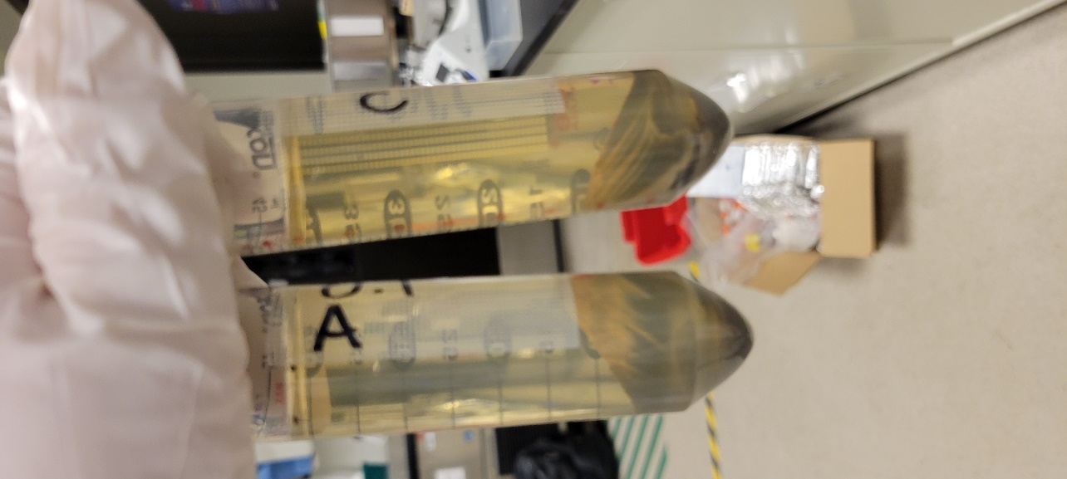

Figure 1) Photograph of A and C replicates of the <0.1 size fraction following the second centrifugation cycle.

The soil in this experiment were collected from the Terrestrial Ecosystem Manipulation to Probe the Effects of Storm Treatments (TEMPEST) experimental forest, which is on the west shore of Chesapeake Bay in MD, USA 6. The study site is located at the Smithsonian Environmental Research Center (SERC). Meteorological data collected between 1981 and 2010 presents mean monthly extremes at 10°C and 20°C and 1,200 mm annual average precipitation. The soil was sent to the Pacific Northwest National Lab, Richland campus to determine texture. Iron and carbon data were previously collected by colleagues at SERC for soil sample and used herein.￼ ￼￼We assembled six experimental systems and prepared them in triplicate and prepared 4 procedural blanks made with either DI water or ASW. The weighed soil was transferred to 50 mL centrifuge tubes for each experimental system.

## Washing and Sample Collection

After the 72-hour pretreatment, half of the samples were exposed to the normal atmosphere and starting to become oxic. At this point, the samples were washed with 35 mL of 25% ASW, which is similar to the salinity of the Rhode River estuary. The ASW was prepared using common salts and procedure for making ASW28. A stock solution of 35% ASW was made and diluted to 25% ASW. Before conducting the experiment, we placed ASW and DI water inside the glovebox so we could have anoxic DI and ASW for our anoxic systems. After washing, the samples were placed on a New Brunswick Science innova 2100 platform shaker set at 270 RPM for 24 hours. After the 24-hour period was over the samples were taken off the shaker table and oxygen was measured (O2%) using a Pyroscience Firesting-GO2 monitor, set for 25°C. The oxygen for the anaerobic samples were measured inside of the Coy chamber.

To obtain the size fractions, we used a Beckman Coulter Avanti J-301 Centrifuge and a JA-25.50 rotor. We collected three size fractions; 0.45-1.0mm (15,000 RCF xg; 9 minutes), 0.1-0.45mm (800 RCF xg; 8 minutes), and <0.1mm (300 RCF xg; 5 minutes)29. The supernatant was collected, and the soil was resuspended with 35 mL of DI water. After collection we aliquoted 5 mL of supernatant into 15 mL falcon tubes to be sent to Argonne National Lab for ICP-MS and we pooled 3 mL from each replicate to later use for CDOM. The samples (now containing DI water) were then placed back on the shaker table. This process was repeated for a total of 5 wash cycles (Wash 1= ASW wash). The anaerobic samples were only handled inside of the glovebox unless they were being prepped for analysis.

Figure 2) A graphical depiction of the methods used for the experiment.

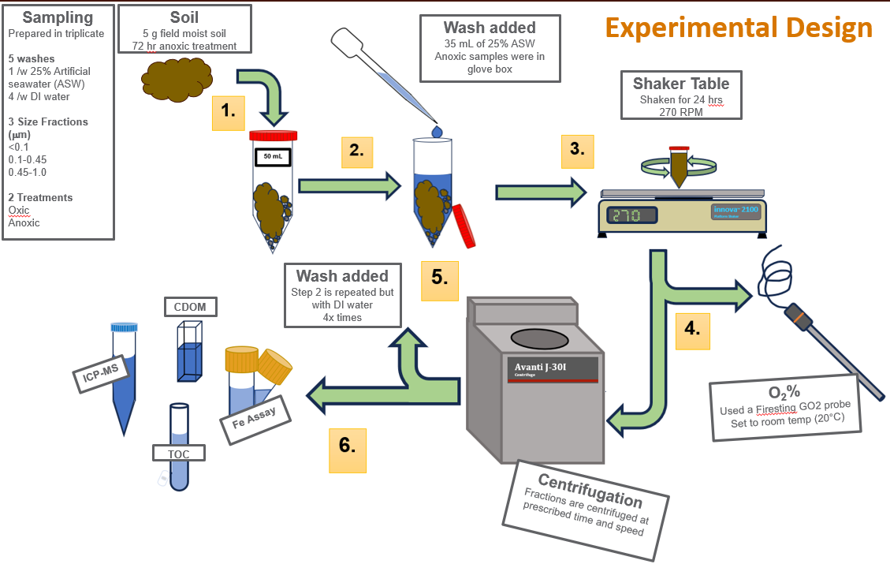

## Chemical Analyses

After collection, 1.8 mL of sample and 200 mL of concentrated HCl were dispensed into 2 mL centrifuge tubes and stored in a 5°C fridge. We sent the samples to be analyzed for Fe (II) and Fe (III) to Pacific Northwest National Lab, Richland Campus. The assay was used to determine Fe(II) and total Fe content in each of our samples30 using a plate reader and the Fe(III) was calculated via subtraction of Fe(II) from the total Fe present.

Total organic carbon was measured on a Shimadzu TOC-L using a high suspension tubing kit. This was done to determine total carbon mobilization and which size fractions contained the most carbon. The 0.1-0.45mm along with the first 3 washes for the 0.45-1.0 mm fractions and the blanks were analyzed without the use of stirrers because they had low enough suspended material but were vortexed before being aliquoted. The >1.0mm fraction and washes 4 and 5 from the 0.45-0.1mm fraction needed to be diluted (they were vortexed beforehand) and stirred while sampling. The samples were stored in a 5°c fridge before analysis and allowed to come to room temperature. Corrected DOC values for the fractions were then calculated via subtraction from previous fractions (i.e., the correct doc values for the 0.45-1.0 mm fraction were calculated by subtracting the 0.1-0.45 mm fraction out. The 0.1-0.45 mm fraction was calculated by subtracting out the <0.1 mm fraction). This was also necessary for the Fe data as well. DOC mobilization was converted from mgC L-1 to mg C per gram soil to normalize for differences in the initial weight of each system.

The carbon characterization was determined by measuring CDOM on a Horiba Scientific Aqualog. The samples were allowed to come to room temperature and were vortexed before being analyzed. We followed the USGS procedure for measuring absorbance and flourescence31. The fluorescence due to OM was corrected using the methods described in Kothwala, et al. (2013) and PARAFAC was used to interpret the EEMs data as presented in Murphy, et al. (2013). Since we had a particular interest in Fe (II and III) we used the methods outlined in Poulin et al. (2014) to correct for Fe(III) in our CDOM samples which we later used to calculate SUVA32. The samples were kept in a 5°C fridge before analysis and allowed to rise to room temp before analysis. We calculated the specific ultraviolet absorbance (SUVA254) for our samples, which measures the amount of light absorbed 254 nm wavelength and is determined by the pathlength and amount of DOC (mg L-1 )33, which has been previously shown to track aromatic OM 34.

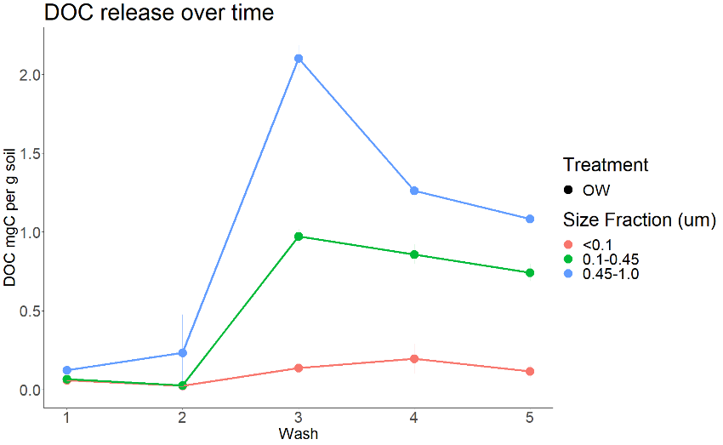

**ASW Wash**

**OW treatment DOC mobilization**

Figure 3) Only the oxic treatment was graphed. The DOC was normalized with the initial mass of soil for better comparison.

# Results and Discussion

## DOC Mobilization and Fraction Size

We found that there was a steady increase in DOC release until the 3rd wash cycle where, across all size fractions, there was a peak followed by a steady decline (Figure 3). This was true for both treatments, however based upon the overlapping error bars between across all fraction sizes, the anoxic treatment (AW) and oxic treatment (OW) were not observably different enough to claim that the redox treatment was triggering any mechanisms (Figure 4). What remained consistent between the treatments was the timing of release of OC and that the 0.45-1.0 mm fraction size contained the most DOC, which was about twice as much as the 0.1-0.45 mm fraction. The <0.1 mm fraction represented the least amount of OC present (6.35% while the other fractions represented 33.98%; 0.1-0.45 mm and 59.65%; 0.45-1.0 mm) and remained relatively stable after the 3rd wash cycle. This matched shifts in DOC following simulated inundation in the TEMPEST6 experiment. In the field changes in the color (which was later linked to DOC content) of porewaters was observed for 1 year following a saltwater inundation event. This also matched a previous experiment conducted at Argonne National Lab focused on investigating ionic strength of artificial seawater (ASW) as a possible mechanism for DOC mobilization from soil. They were able to determine that with increasing ionic strength there is an increase in the mobilization of DOC, most noticeable after several days/washes.

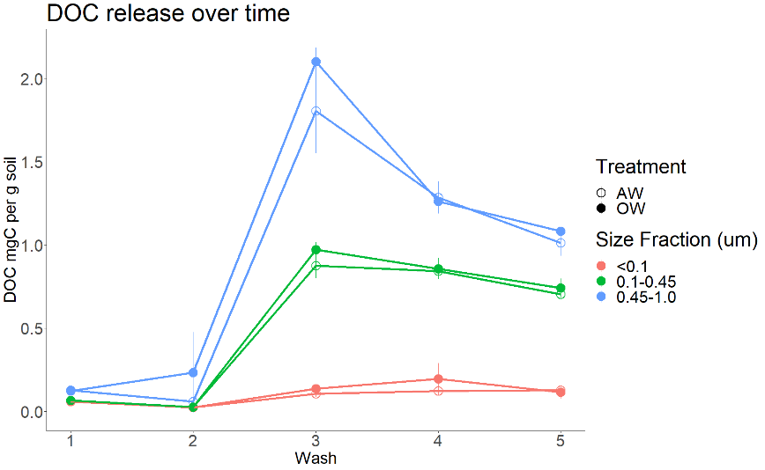

**ASW Wash**

**Both treatments and DOC mobilization**

Figure 4) The DOC was normalized with the initial mass of soil for better comparison. No difference between treatments

## Effect of ionic strength on DOC release

The ionic strength of the solution has been shown to a have a negative relationship with the absorption of DOM to minerals 17. We observed an increase in DOC mobilization after saltwater inundation and several DI washes (Figures 3&4). We expect this to be due to the ionic strength of the solution adjusting to the electrochemical gradient and establishing equilibirum with the surrounding solution by releasing cations/anions and freeing up space for OM ligands to bind with minerals again. If we plot salinity versus each of our washes (Figure 5) we see that the decrease in concentration of ions remains the same for both treatments and across all fractions, However, there is no difference in salinity across fractions or between treatments so the variation in DOC release must be more directly influenced by another mechanism.

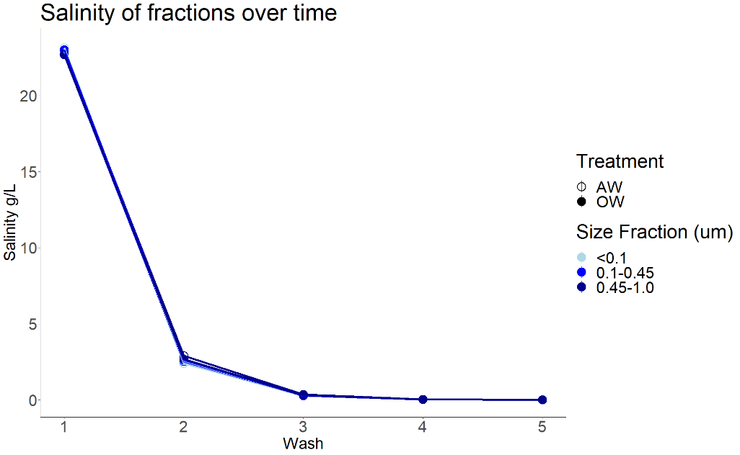

Figure 5) Salinity was calculated from measuring the conductivity of each sample. Notice how it looks like only one line is present.

## Fe(III) is an important metal in OC adsorption

The other mechanism that we were interested in investigating was the complexes formed by Fe and OM. Fe oxides seem to be the most important sorbents for subsurface biogeochemistry35. As the experiment progress we saw considerably more Fe(III) across fractions and saw a large shift from Fe(II) to Fe(III) at during the 3rd wash which would coincide with the release of DOC and suggest that they being transported together (Figure 6). Unlike the salinity data, there are differences between the fractions and the is a shift in the relative abundance of the two Fe species, which may account for the variability we see in the DOC. Fe(III) shows the same trends as the DOC in the system (Figure 7; Wash 3 is the peak and we see no differences between treatments).

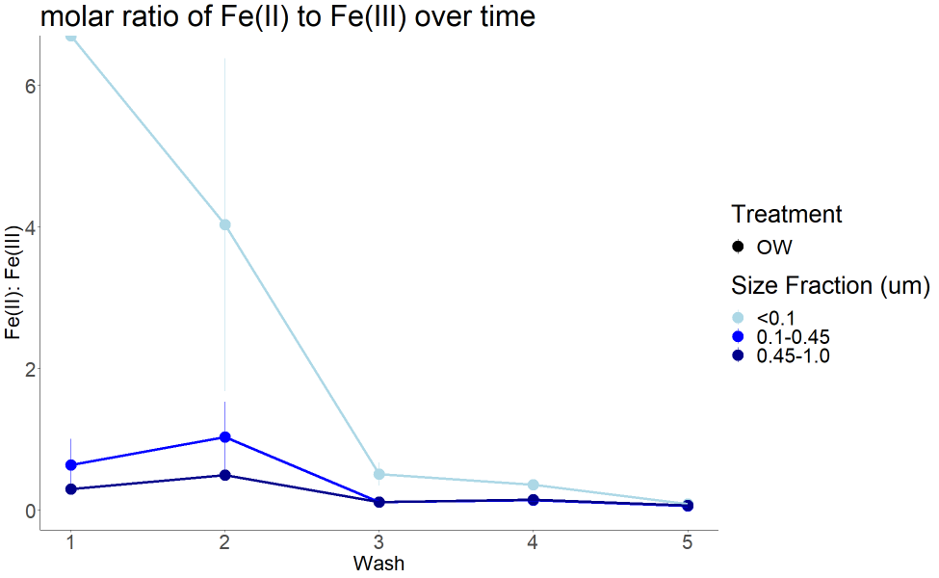

Figure 6) Molar ratio of Fe(II) to Fe(III) is shown in order to understand where the different species are in the fragments and how the concentrations change in relation to one another. A smaller ratio means more Fe(III)

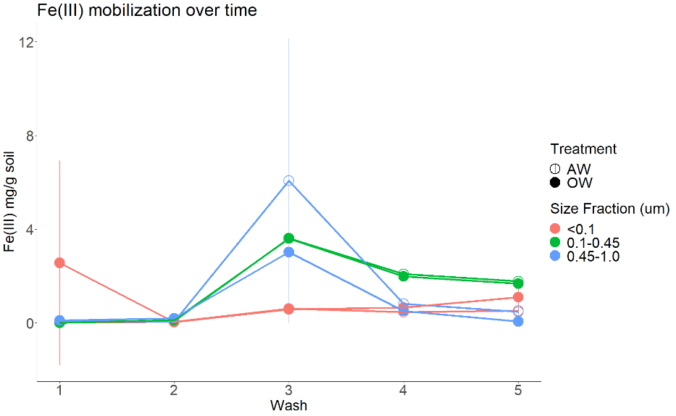

Figure 7) Fe(III) mg per g of soil over time. This data was also normalized with the initial mass of soil used for each replicate.

## Fe(III) and OM complexes

To help understand where and in what form Fe(III) is being released, we used the molar ratio of Fe:OC because it has been hypothesized to reflect the relative abundance of organically complexed Fe versus colloidal FeOOH 20. According to this assumption, the <0.1 mm fraction appears to have mostly colloidal FeOOH while the mid-sized fraction and largest fraction contain mostly Fe-OM complexes (Figure 8) highlighting the difference in size fractions that would not have been available by just looking at the concentration of Fe(III). Across ionic strength gradients, it has been shown for aromatic OM to preferentially associate with Fe(III) in boreal rivers and marine systems20. We plotted the concentration of Fe(III) against SUVA254 and calculated a linear regression model to uncover whether we were observing the same relationship in coastal upland forest (Figure 9). There is a slightly positive relationship between the concentration of Fe(III) and the aromaticity of the OM across all fractions. The first two washes for all fractions seem to be clustered together close to (0,0) and start to vary as both variables increase.

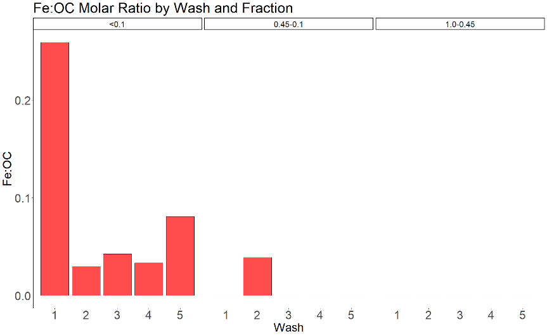

Figure 8) The molar ratio of Fe and OC found in each wash and displayed based upon fraction size. In this ratio, the smaller it is the more organically complexed Fe is present.

# Conclusions

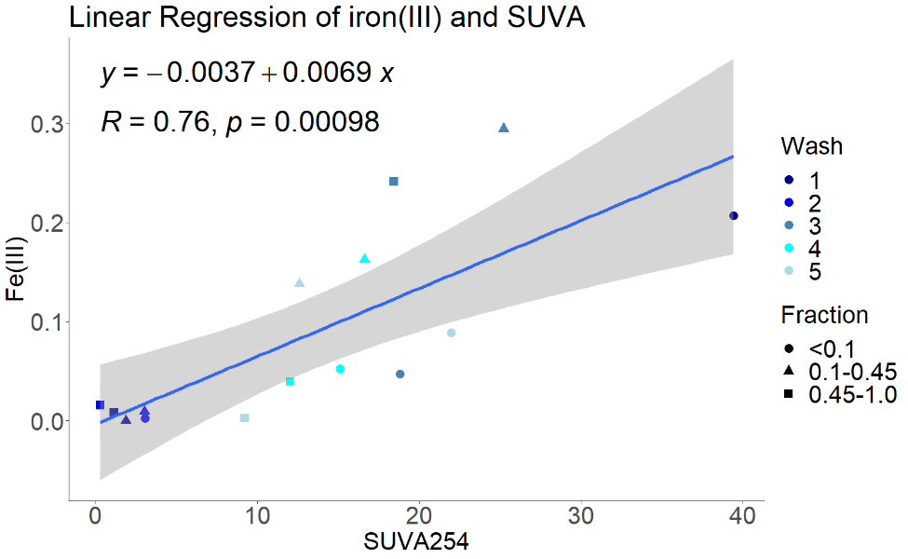

Figure 9) Linear regression of molar concentration of Fe(III) and SUVA. SUVA is a value calculated to represent the aromaticity of OM. The larger the value the more aromatic.

Saltwater inundation of coastal upland forest will have large ecosystem scale consequences that we do not yet fully understand. Our research into the mechanisms that influence DOC mobilization may help to further disentangle the relationships between chemical variables (ionic strength, DOC, Fe(III) that can be used to infer how storm surge and/or sea level rise may influence carbon turnover rates and stability. The ionic strength of a solution and the Fe-OM associations have been shown to cause variation in how DOC is moving from the soil in different colloidal fragments26,36. We have found that OC was largely being mobilized in the mid to upper size fractions and that redox treatment did not have an observable impact on DOC release in our experiments. We believe that as the ionic strength starts to decrease and the electrostatic repulsion from the cations decreases, the recently oxidized Fe(III) is starting to selectively aggregate with aromatic OM. We can assert that following saltwater inundation, Fe-OM interactions can provide a potential mechanism for DOC mobilization in coastal upland forest.

## Acknowledgements

I would like to give thanks to my mentor, Allison Myers-Pigg for the support and guidance she gave me. This project would not have been possible without her expertise and advice. I would also like to thank, Nick Ward for being a co-mentor and helping develop the methods and main ideas behind this project. I would also like to thank Kaizad Patel, Edward O’Loughlin, and Alan Roebuck for their help in analyzing samples and helping to interpolate data. Lastly, I would like to acknowledge the SULI program and DOE, for which without their funding, I would not have had the opportunity to work with the amazing people listed.

# Works Cited

1 J.D. Boon, “Evidence of Sea Level Acceleration at U.S. and Canadian Tide Stations, Atlantic Coast, North America,” Coas **28**(6), 1437–1445 (2012).

2 M.A. Bender, T.R. Knutson, R.E. Tuleya, J.J. Sirutis, G.A. Vecchi, S.T. Garner, and I.M. Held, “Modeled Impact of Anthropogenic Warming on the Frequency of Intense Atlantic Hurricanes,” Science **327**(5964), 454–458 (2010).

3“Climate Extremes and Variability Surrounding Chesapeake Bay: Past, Present, and Future - St.Laurent - 2022 - JAWRA Journal of the American Water Resources Association - Wiley Online Library,” (n.d.).

4 R.S.J. Tol, T.E. Downing, O.J. Kuik, and J.B. Smith, “Distributional aspects of climate change impacts,” Global Environmental Change **14**(3), 259–272 (2004).

5 C. Bellard, C. Bertelsmeier, P. Leadley, W. Thuiller, and F. Courchamp, “Impacts of climate change on the future of biodiversity,” Ecology Letters **15**(4), 365–377 (2012).

6 A.M. Hopple, K.O. Doro, V.L. Bailey, B. Bond-Lamberty, N. McDowell, K.A. Morris, A. Myers-Pigg, S.C. Pennington, P. Regier, R. Rich, A. Sengupta, R. Smith, J. Stegen, N.D. Ward, S.C. Woodard, and J.P. Megonigal, “Attaining freshwater and estuarine-water soil saturation in an ecosystem-scale coastal flooding experiment,” Environ Monit Assess **195**(3), 425 (2023).

7 S. Fettrow, R. Vargas, and A.L. Seyfferth, “Experimentally simulated sea level rise destabilizes carbon-mineral associations in temperate tidal marsh soil,” Biogeochemistry **163**(2), 103–120 (2023).

8 V. Bailey, C. Pries, and K. Lajtha, “What do we know about soil carbon destabilization? - IOPscience,” IOPScience, (2019).

9 Q. Zhao, S. Dunham-Cheatham, D. Adhikari, C. Chen, A. Patel, S.R. Poulson, D. Obrist, P.S.J. Verburg, X. Wang, E.R. Roden, A. Thompson, and Y. Yang, “Oxidation of soil organic carbon during an anoxic-oxic transition,” Geoderma **377**, 114584 (2020).

10“Root and Microbial Soil CO2 and CH4 Fluxes Respond Differently to Seasonal and Episodic Environmental Changes in a Temperate Forest - Hopple - 2023 - Journal of Geophysical Research: Biogeosciences - Wiley Online Library,” (n.d.).

11 J. Kopáček, C.D. Evans, J. Hejzlar, J. Kaňa, P. Porcal, and H. Šantrůčková, “Factors Affecting the Leaching of Dissolved Organic Carbon after Tree Dieback in an Unmanaged European Mountain Forest,” Environ. Sci. Technol. **52**(11), 6291–6299 (2018).

12 K.L. Mcinnes, K.J.E. Walsh, G.D. Hubbert, and T. Beer, “Impact of Sea-level Rise and Storm Surges on a Coastal Community,” Natural Hazards **30**(2), 187–207 (2003).

13 J. Camelo, T.L. Mayo, and E.D. Gutmann, “Projected Climate Change Impacts on Hurricane Storm Surge Inundation in the Coastal United States,” Front. Built Environ. **6**, (2020).

14 D. Weissman, T. Ouyang, and K.L. Tully, “Saltwater intrusion affects nitrogen, phosphorus and iron transformations under oxic and anoxic conditions: an incubation experiment,” Biogeochemistry **154**(3), 451–469 (2021).

15 E.A. Ury, J.P. Wright, M. Ardón, and E.S. Bernhardt, “Saltwater intrusion in context: soil factors regulate impacts of salinity on soil carbon cycling,” Biogeochemistry **157**(2), 215–226 (2022).

16 F. Dou, C.-L. Ping, L. Guo, and T. Jorgenson, “Estimating the Impact of Seawater on the Production of Soil Water-Extractable Organic Carbon during Coastal Erosion,” Journal of Environmental Quality **37**(6), 2368–2374 (2008).

17 E.J. Tomaszewski, E.K. Coward, and D.L. Sparks, “Ionic Strength and Species Drive Iron–Carbon Adsorption Dynamics: Implications for Carbon Cycling in Future Coastal Environments,” Environ. Sci. Technol. Lett. **8**(8), 719–724 (2021).

18 R.L. Wilby, and R. Keenan, “Adapting to flood risk under climate change,” Progress in Physical Geography: Earth and Environment **36**(3), 348–378 (2012).

19 S.-C. Hsiao, W.-S. Chiang, J.-H. Jang, H.-L. Wu, W.-S. Lu, W.-B. Chen, and Y.-T. Wu, “Flood risk influenced by the compound effect of storm surge and rainfall under climate change for low-lying coastal areas,” Science of The Total Environment **764**, 144439 (2021).

20 S.D. Herzog, P. Persson, and E.S. Kritzberg, “Salinity Effects on Iron Speciation in Boreal River Waters,” Environ. Sci. Technol. **51**(17), 9747–9755 (2017).

21 M. Barczok, C. Smith, N. Di Domenico, L. Kinsman-Costello, D. Singer, and E. Herndon, “Influence of contrasting redox conditions on iron (oxyhydr)oxide transformation and associated phosphate sorption,” Biogeochemistry **166**(2), 87–107 (2023).

22 G. Aiken, and J. Leenheer, “Isolation and Chemical Characterization of Dissolved and Colloidal Organic Matter,” Chemistry and Ecology **8**(3), 135–151 (1993).

23 T. Bao, P. Wang, B. Hu, X. Wang, and J. Qian, “Mobilization of colloids during sediment resuspension and its effect on the release of heavy metals and dissolved organic matter,” Science of The Total Environment **861**, 160678 (2023).

24 L.K. ThomasArrigo, and R. Kretzschmar, “Iron speciation changes and mobilization of colloids during redox cycling in Fe-rich, Icelandic peat soils,” Geoderma **428**, 116217 (2022).

25 M.Z. Afsar, C. Goodwin, T.P. Beebe, D.P. Jaisi, and Y. Jin, “Quantification and molecular characterization of organo-mineral associations as influenced by redox oscillations,” Science of The Total Environment **704**, 135454 (2020).

26 M. Kleber, I.C. Bourg, E.K. Coward, C.M. Hansel, S.C.B. Myneni, and N. Nunan, “Dynamic interactions at the mineral–organic matter interface,” Nat Rev Earth Environ **2**(6), 402–421 (2021).

27 A. Bhattacharyya, A.N. Campbell, M.M. Tfaily, Y. Lin, R.K. Kukkadapu, W.L. Silver, P.S. Nico, and J. Pett-Ridge, “Redox Fluctuations Control the Coupled Cycling of Iron and Carbon in Tropical Forest Soils,” Environ. Sci. Technol. **52**(24), 14129–14139 (2018).

28“PREPARATION OF ARTIFICIAL SEAWATER1,” (n.d.).

29 N.D. Ward, M. Bowe, K.A. Muller, X. Chen, Q. Zhao, R. Chu, Z. Cheng, T.W. Wietsma, and R.K. Kukkadapu, *Interactive Effects of Salinity, Redox State, Soil Type, and Colloidal Size Fractionation on Greenhouse Gas Production in Coastal Wetland Soils* (Preprints, 2023).

30 J. Riemer, H.H. Hoepken, H. Czerwinska, S.R. Robinson, and R. Dringen, “Colorimetric ferrozine-based assay for the quantitation of iron in cultured cells,” Analytical Biochemistry **331**(2), 370–375 (2004).

31 A. Hansen, J. Fleck, T. Kraus, B. Downing, T. Dessonneck, and B. Bergamaschi, *Procedures for Using the Horiba Scientific Aqualog Flourometer to Measure Absorbance and Flourescence from Dissolved Organic Matter* (USGS, 2018), p. 42.

32 T.S.B. Abd Manan, T. Khan, W.H.M. Wan Mohtar, S. Beddu, N.L. Mohd Kamal, S. Yavari, H. Jusoh, S. Qazi, S.K.B. Imam Supaat, F. Adnan, A.A. Ghanim, S. Yavari, A. Machmudah, A. Rajabi, M. Porhemmat, M. Irfan, M.T. Abdullah, and E.S.B. Abdul Shakur, “Dataset on specific UV absorbances (SUVA254) at stretch components of Perak River basin,” Data in Brief **30**, 105518 (2020).

33 A.D. Pifer, and J.L. Fairey, “Improving on SUVA254 using fluorescence-PARAFAC analysis and asymmetric flow-field flow fractionation for assessing disinfection byproduct formation and control,” Water Research **46**(9), 2927–2936 (2012).

34 T. Broder, K.-H. Knorr, and H. Biester, “Changes in dissolved organic matter quality in a peatland and forest headwater stream as a function of seasonality and hydrologic conditions,” Hydrology and Earth System Sciences **21**(4), 2035–2051 (2017).

35 I. Kögel-Knabner, G. Guggenberger, M. Kleber, E. Kandeler, K. Kalbitz, S. Scheu, K. Eusterhues, and P. Leinweber, “Organo-mineral associations in temperate soils: Integrating biology, mineralogy, and organic matter chemistry,” Journal of Plant Nutrition and Soil Science **171**(1), 61–82 (2008).

36“Characterization of Iron and Organic Carbon Colloids in Boreal Rivers and Their Fate at High Salinity - Herzog - 2020 - Journal of Geophysical Research: Biogeosciences - Wiley Online Library,” (n.d.).

37 K. R. Murphy, C. A. Stedmon, D. Graeber, and R. Bro, “Fluorescence spectroscopy and multi-way techniques. PARAFAC,” Analytical Methods **5**(23), 6557–6566 (2013).

38 D.N. Kothawala, K.R. Murphy, C.A. Stedmon, G.A. Weyhenmeyer, and L.J. Tranvik, “Inner filter correction of dissolved organic matter fluorescence,” Limnology and Oceanography: Methods **11**(12), 616–630 (2013).

39 B.A. Poulin, J.N. Ryan, and G.R. Aiken, “Effects of Iron on Optical Properties of Dissolved Organic Matter,” Environ. Sci. Technol. **48**(17), 10098–10106 (2014).